1)

package com.example.demo.test_maven;

import org.openqa.selenium.By;

import org.openqa.selenium.WebDriver;

import org.openqa.selenium.WebElement;

import org.openqa.selenium.chrome.ChromeDriver;

import org.openqa.selenium.chrome.ChromeOptions;

import org.openqa.selenium.interactions.Actions;

import io.github.bonigarcia.wdm.WebDriverManager;

public class App {

    public static void main(String[] args) {

        // TODO Auto-generated method stub

        WebDriverManager.chromedriver().setup();

        WebDriver  driver;

        ChromeOptions co = new ChromeOptions();

        co.addArguments("--remote-allow-origins=*");

        driver=new ChromeDriver(co);

        driver.get("https://demoqa.com/droppable/");

        //creating Elements for drag and drop

//      WebElement drag=driver.findElement(By.id("draggable"));

//      WebElement drop=driver.findElement(By.id("droppable"));

        WebElement drag=driver.findElement(By.id("draggable"));

        WebElement drop=driver.findElement(By.id("droppable"));

        Actions act=new Actions(driver);

        act.dragAndDrop(drag, drop).build().perform();

        //doing actions

//      Actions act=new Actions(driver);

//      act.dragAndDrop(drag, drop).build().perform();

    }

}

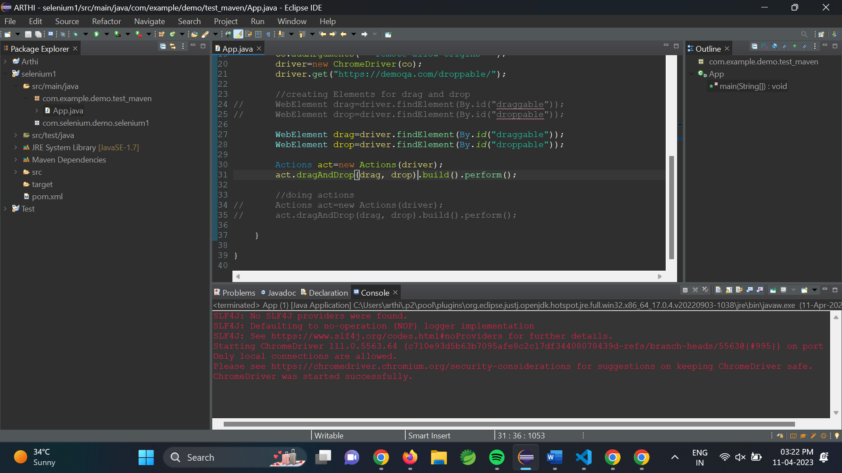

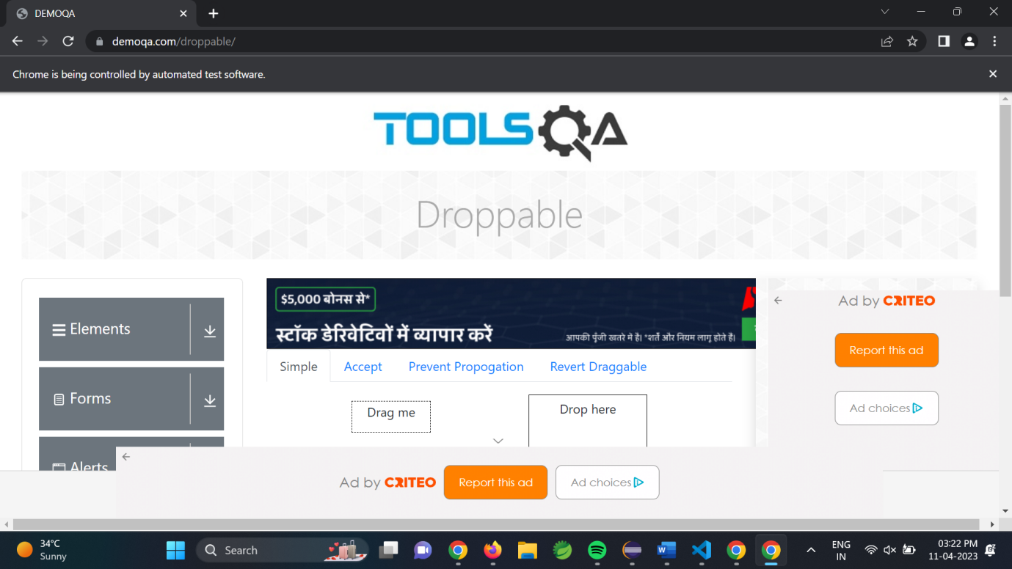

2)

package com.example.demo.test_maven;

import org.openqa.selenium.By;

import org.openqa.selenium.WebDriver;

import org.openqa.selenium.WebElement;

import org.openqa.selenium.chrome.ChromeDriver;

import org.openqa.selenium.chrome.ChromeOptions;

import org.openqa.selenium.interactions.Actions;

import io.github.bonigarcia.wdm.WebDriverManager;

public class App

    public static void main(String[] args) {

        // TODO Auto-generated method stub

        WebDriverManager.chromedriver().setup();

        WebDriver  driver;

        ChromeOptions co = new ChromeOptions();

        co.addArguments("--remote-allow-origins=*");

        driver=new ChromeDriver(co);

        driver.get("https://jqueryui.com/droppable/");

        driver.switchTo().frame(0);

        WebElement drag1=driver.findElement(By.id("draggable"));

        Actions act=new Actions(driver);

        WebElement drop1=driver.findElement(By.id("droppable"));

        act.dragAndDrop(drag1, drop1).build().perform();

    }

}

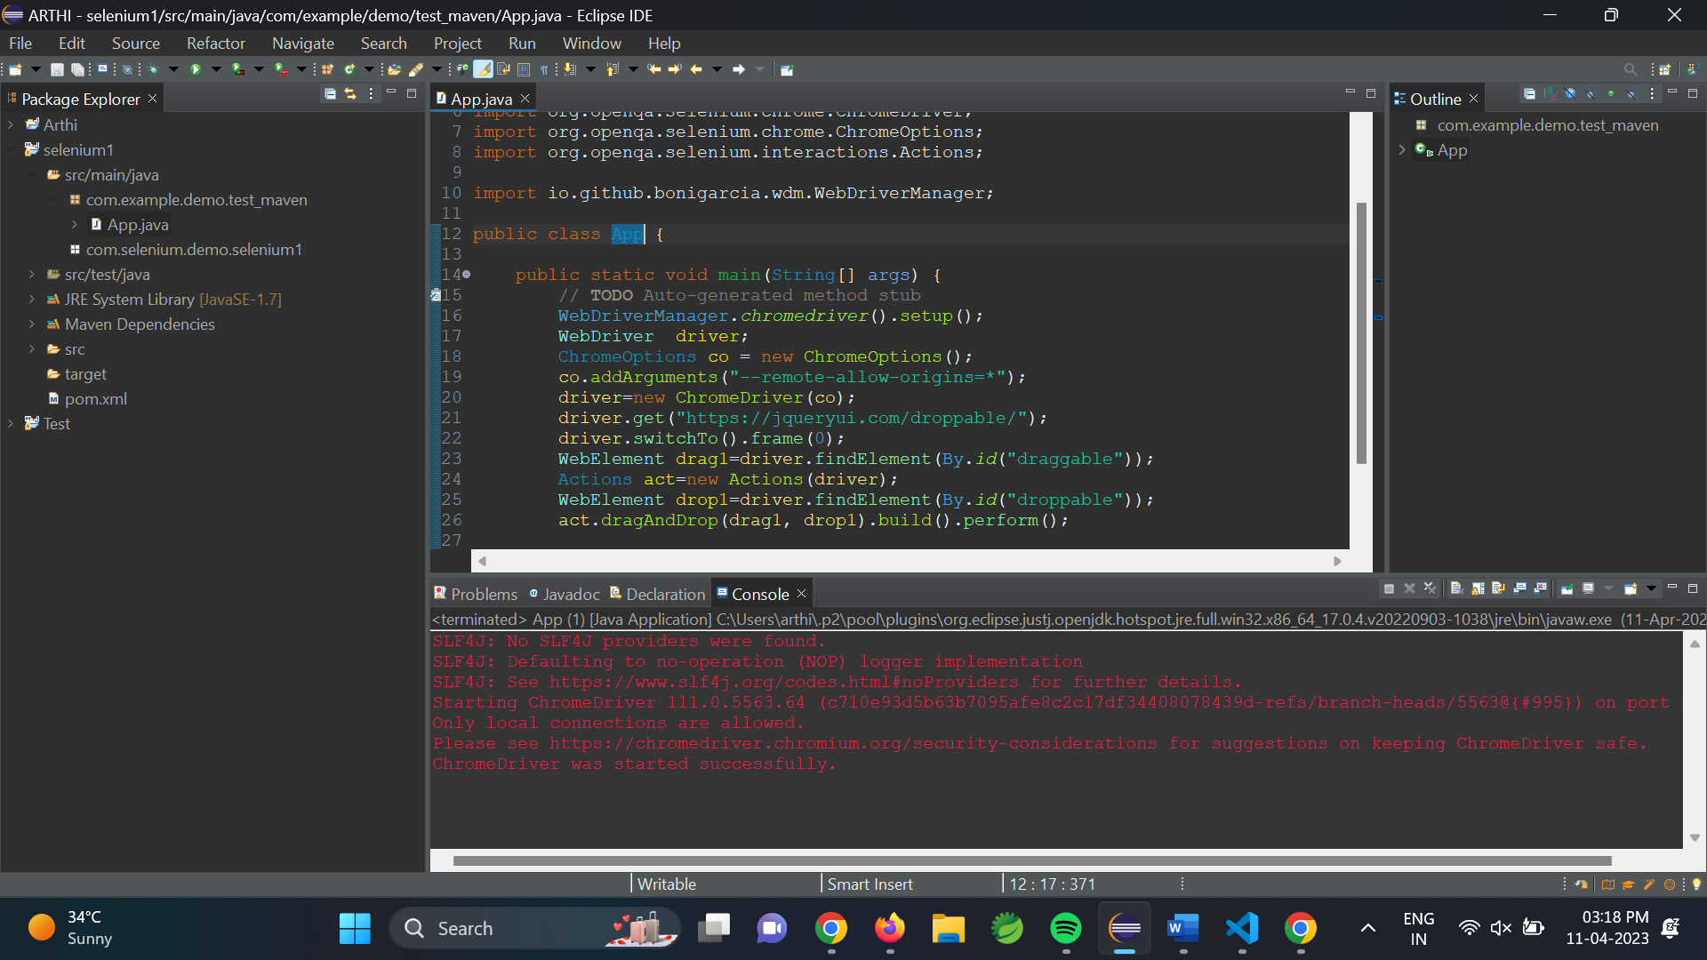

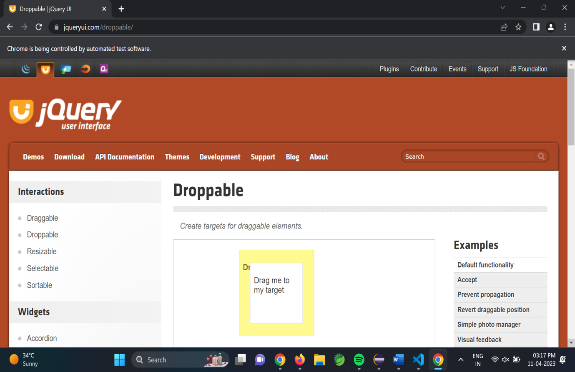

3)

package com.example.demo.test_maven;

import org.openqa.selenium.Alert;

import org.openqa.selenium.By;

import org.openqa.selenium.WebDriver;

import org.openqa.selenium.WebElement;

import org.openqa.selenium.chrome.ChromeDriver;

import org.openqa.selenium.chrome.ChromeOptions;

import io.github.bonigarcia.wdm.WebDriverManager;

public class App{

    public static void main(String[] args) throws Exception {

        // TODO Auto-generated method stub

        WebDriverManager.chromedriver().setup();

        WebDriver  driver;

        ChromeOptions co = new ChromeOptions();

        co.addArguments("--remote-allow-origins=*");

        driver=new ChromeDriver(co);

        driver.get("https://demo.guru99.com/test/delete_customer.php");

        driver.manage().window().maximize();

        //enter 401 and clicking

        WebElement txt1=driver.findElement(By.name("cusid"));

        txt1.sendKeys("401");

        driver.findElement(By.name("submit")).click();

        //handling alert boxes

        Alert alt=driver.switchTo().alert();

        Thread.sleep(4000);

        alt.dismiss();

        txt1.clear();

        txt1.sendKeys("402");

        driver.findElement(By.name("submit")).click();

        alt.accept();

        Alert alt2=driver.switchTo().alert();

        String txt=alt2.getText();

        alt2.accept();

        System.out.println(txt);

    }

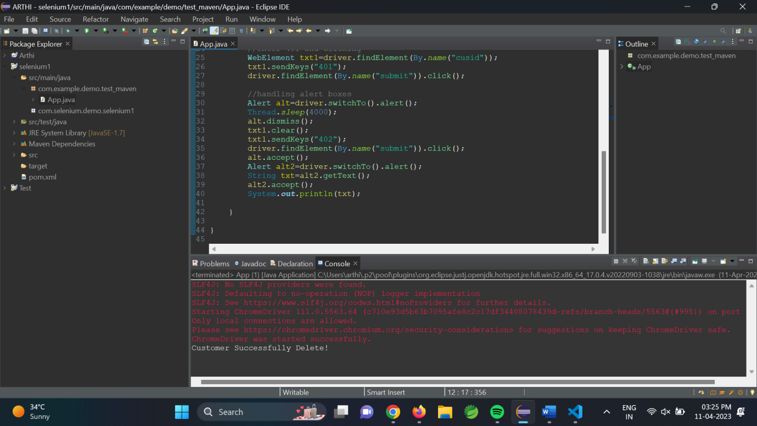

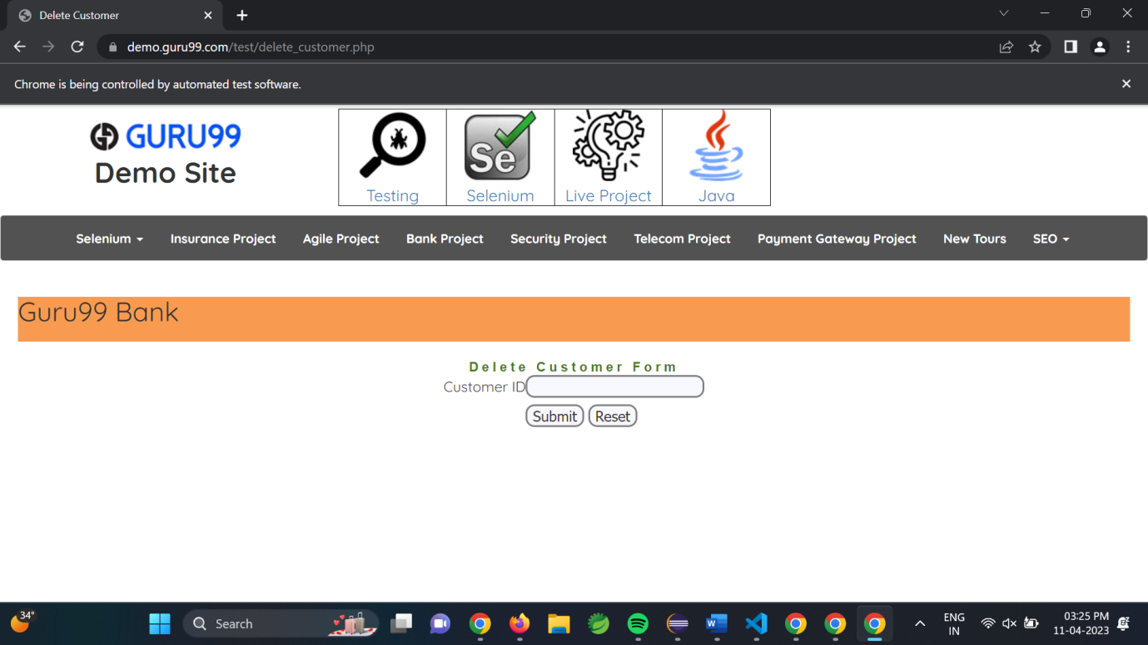

4)

package com.example.demo.test_maven;

import org.openqa.selenium.By;

import org.openqa.selenium.JavascriptExecutor;

import org.openqa.selenium.Keys;

import org.openqa.selenium.WebDriver;

import org.openqa.selenium.WebElement;

import org.openqa.selenium.edge.EdgeDriver;

import io.github.bonigarcia.wdm.WebDriverManager;

public class App {

    public static void main(String[] args) {

        WebDriverManager.edgedriver().setup();

        WebDriver driver = new EdgeDriver();

        driver.manage().window().maximize();

        driver.get("https://www.abhibus.com/bus-ticket-booking");

        //selecting and entering source

        WebElement d=driver.findElement(By.xpath("//*[@id=\"source\"]"));

        d.sendKeys("Coimbatore");

        //selecting and entering destination

        driver.findElement(By.xpath("//*[@id=\"destination\"]")).sendKeys("Chennai");

        //Datepicker

        WebElement dp=driver.findElement(By.xpath("//*[@id=\"datepicker1\"]"));

        JavascriptExecutor js=(JavascriptExecutor) driver;

        js.executeScript("arguments[0].setAttribute('value', '04/10/2023')", dp);

    }

}

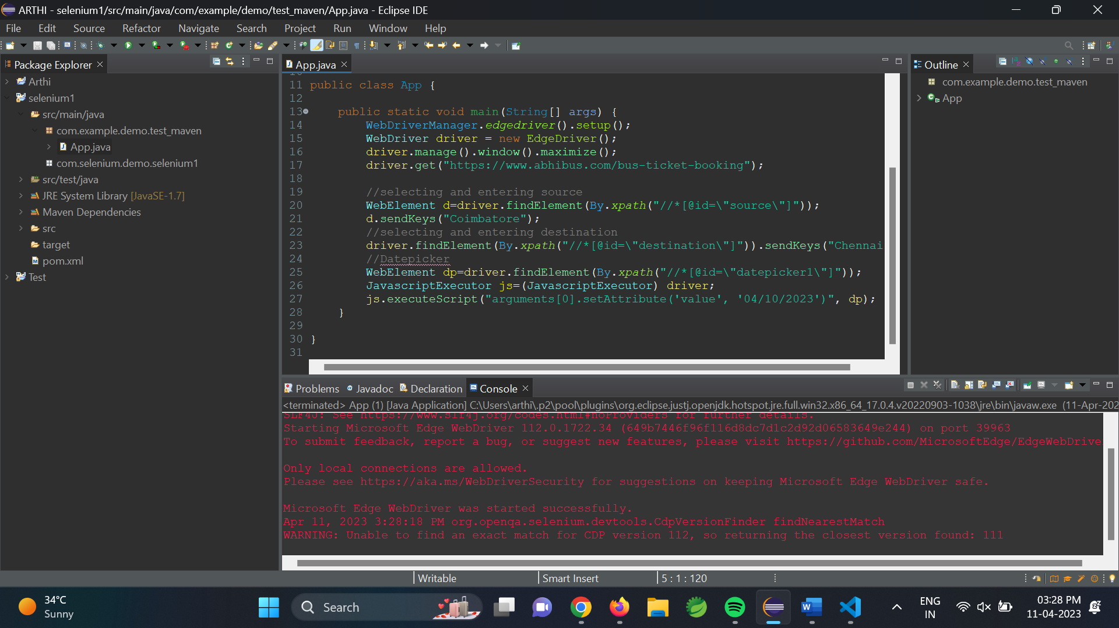

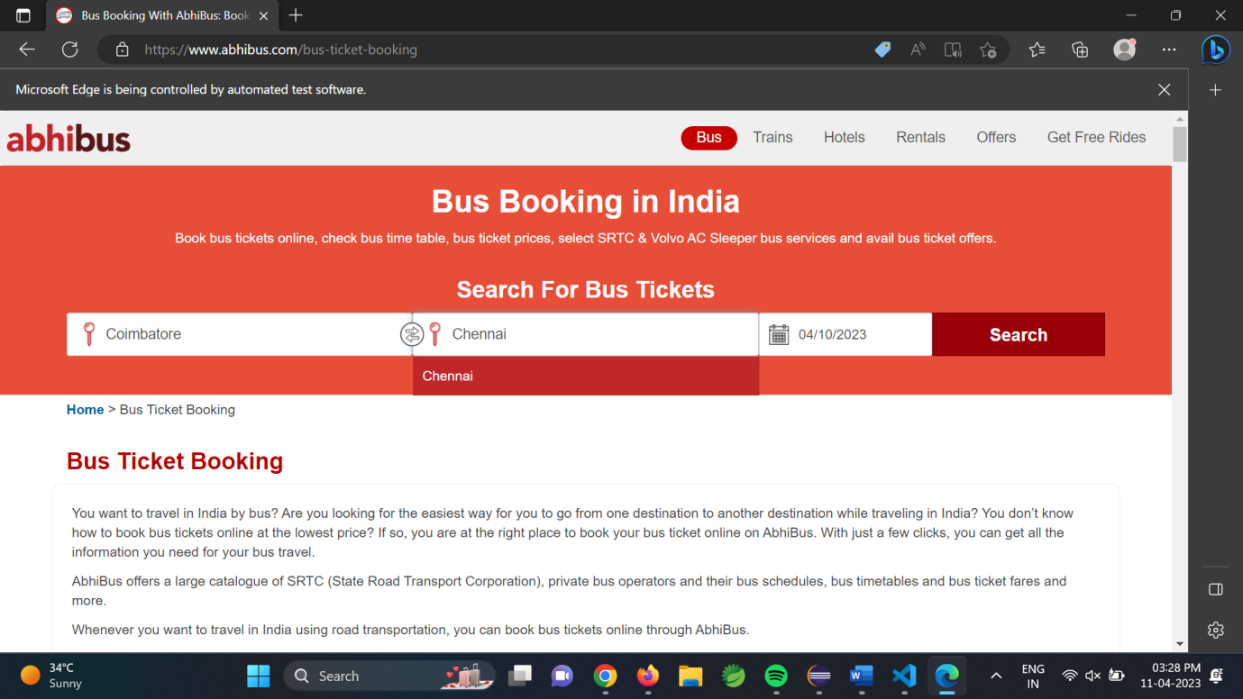

package com.example.demo.test_maven;

import java.util.Iterator;

import java.util.Set;

import org.openqa.selenium.By;

import org.openqa.selenium.Keys;

import org.openqa.selenium.WebDriver;

import org.openqa.selenium.WindowType;

import org.openqa.selenium.chrome.ChromeDriver;

import org.openqa.selenium.chrome.ChromeOptions;

import io.github.bonigarcia.wdm.WebDriverManager;

public class App{

    public static void main(String[] args) {

        // TODO Auto-generated method stub

        //chrome

        WebDriverManager.chromedriver().setup();

        ChromeOptions co=new ChromeOptions();

        co.addArguments("--remote-allow-origins=*");

        WebDriver driver=new ChromeDriver(co);

        driver.get("https://google.com");

        driver.manage().window().maximize();

        driver.findElement(By.name("q")).sendKeys("Apple");

        driver.findElement(By.name("q")).sendKeys(Keys.ENTER);

        String parent=driver.getWindowHandle();

        System.out.println(parent);

        System.out.println(driver.getTitle());

        driver.switchTo().newWindow(WindowType.TAB);

        driver.get("https://google.com");

        driver.manage().window().maximize();

        driver.findElement(By.name("q")).sendKeys("Selenium");

        driver.findElement(By.name("q")).sendKeys(Keys.ENTER);

        driver.switchTo().newWindow(WindowType.TAB);

        driver.get("https://google.com");

        driver.manage().window().maximize();

        driver.findElement(By.name("q")).sendKeys("Cucumber");

        driver.findElement(By.name("q")).sendKeys(Keys.ENTER);

        Set<String>s=driver.getWindowHandles();

        Iterator<String> I1=s.iterator();

        while(I1.hasNext())

        {

            String child=I1.next();

            if(!parent.equals(child))

            {driver.switchTo().window(child);

                System.out.println(driver.switchTo().window(child).getWindowHandle());

                System.out.println(driver.switchTo().window(child).getTitle())





